**Week - 1**

**(08 June 2023)**

**Experiment - 1**

**Question:**

Write a C program to perform the following operations on matrices:

Addition, Subtraction, Multiplication, Row Sum, Column Sum, Transpose, Principal Diagonal Sum, Non-principal Diagonal Sum, Check whether the matrices are symmetrical or not.

**Program:**

#include <stdio.h>

#define MAX_SIZE 10

void matrixAddition(int mat1[][MAX_SIZE], int mat2[][MAX_SIZE], int result[][MAX_SIZE], int rows, int cols) {

int i, j;

for (i = 0; i < rows; i++) {

for (j = 0; j < cols; j++) {

result[i][j] = mat1[i][j] + mat2[i][j];

}

}

}

void matrixSubtraction(int mat1[][MAX_SIZE], int mat2[][MAX_SIZE], int result[][MAX_SIZE], int rows, int cols) {

int i, j;

for (i = 0; i < rows; i++) {

for (j = 0; j < cols; j++) {

result[i][j] = mat1[i][j] - mat2[i][j];

}

}

}

void matrixMultiplication(int mat1[][MAX_SIZE], int mat2[][MAX_SIZE], int result[][MAX_SIZE], int rows1, int cols1, int cols2) {

int i, j, k;

for (i = 0; i < rows1; i++) {

for (j = 0; j < cols2; j++) {

result[i][j] = 0;

for (k = 0; k < cols1; k++) {

result[i][j] += mat1[i][k] * mat2[k][j];

}

}

}

}

int isSymmetric(int mat[][MAX_SIZE], int rows, int cols) {

int i, j;

for (i = 0; i < rows; i++) {

for (j = 0; j < cols; j++) {

if (mat[i][j] != mat[j][i]) {

return 0; // Not symmetric

}

}

}

return 1; // Symmetric

}

int findPrincipalDiagonalSum(int mat[][MAX_SIZE], int rows, int cols) {

int i, sum = 0;

for (i = 0; i < rows && i < cols; i++) {

sum += mat[i][i];

}

return sum;

}

int findNonPrincipalDiagonalSum(int mat[][MAX_SIZE], int rows, int cols) {

int i, j, sum = 0;

for (i = 0, j = cols - 1; i < rows && j >= 0; i++, j--) {

sum += mat[i][j];

}

return sum;

}

void findRowSums(int mat[][MAX_SIZE], int rows, int cols, int rowSums[]) {

int i, j;

for (i = 0; i < rows; i++) {

rowSums[i] = 0;

for (j = 0; j < cols; j++) {

rowSums[i] += mat[i][j];

}

}

}

void findColumnSums(int mat[][MAX_SIZE], int rows, int cols, int colSums[]) {

int i, j;

for (j = 0; j < cols; j++) {

colSums[j] = 0;

for (i = 0; i < rows; i++) {

colSums[j] += mat[i][j];

}

}

}

void findMatrixTranspose(int mat[][MAX_SIZE], int rows, int cols, int transpose[][MAX_SIZE]) {

int i, j;

for (i = 0; i < rows; i++) {

for (j = 0; j < cols; j++) {

transpose[j][i] = mat[i][j];

}

}

}

void displayMatrix(int mat[][MAX_SIZE], int rows, int cols) {

int i, j;

for (i = 0; i < rows; i++) {

for (j = 0; j < cols; j++) {

printf("%d ", mat[i][j]);

}

printf("\n");

}

printf("\n");

}

int main() {

int mat1[MAX_SIZE][MAX_SIZE], mat2[MAX_SIZE][MAX_SIZE], result[MAX_SIZE][MAX_SIZE];

int rows1, cols1, rows2, cols2;

printf("Enter the number of rows and columns for the first matrix: ");

scanf("%d %d", &rows1, &cols1);

printf("Enter the elements of the first matrix:\n");

int i, j;

for (i = 0; i < rows1; i++) {

for (j = 0; j < cols1; j++) {

scanf("%d", &mat1[i][j]);

}

}

printf("Enter the number of rows and columns for the second matrix: ");

scanf("%d %d", &rows2, &cols2);

printf("Enter the elements of the second matrix:\n");

for (i = 0; i < rows2; i++) {

for (j = 0; j < cols2; j++) {

scanf("%d", &mat2[i][j]);

}

}

// Perform matrix addition

if (rows1 == rows2 && cols1 == cols2) {

matrixAddition(mat1, mat2, result, rows1, cols1);

printf("\nResult of matrix addition:\n");

displayMatrix(result, rows1, cols1);

} else {

printf("\nMatrix addition is not possible. The matrices must have the same dimensions.\n");

}

// Perform matrix Subtraction

if (rows1 == rows2 && cols1 == cols2) {

matrixSubtraction(mat1, mat2, result, rows1, cols1);

printf("\nResult of matrix subtraction:\n");

displayMatrix(result, rows1, cols1);

} else {

printf("\nMatrix subtraction is not possible. The matrices must have the same dimensions.\n");

}

// Perform matrix multiplication

if (cols1 == rows2) {

matrixMultiplication(mat1, mat2, result, rows1, cols1, cols2);

printf("\nResult of matrix multiplication:\n");

displayMatrix(result, rows1, cols2);

} else {

printf("\nMatrix multiplication is not possible. The number of columns in the first matrix must be equal to the number of rows in the second matrix.\n");

}

// Check if matrices are symmetric

printf("Checking if matrices are symmetric...\n");

int isMat1Symmetric = isSymmetric(mat1, rows1, cols1);

int isMat2Symmetric = isSymmetric(mat2, rows2, cols2);

if (isMat1Symmetric)

printf("\nMatrix 1 is symmetric.\n");

else

printf("\nMatrix 1 is not symmetric.\n");

if (isMat2Symmetric)

printf("\nMatrix 2 is symmetric.\n");

else

printf("\nMatrix 2 is not symmetric.\n");

// Find sum of principal and non-principal diagonals of matrix 1

int principalDiagonalSum1 = findPrincipalDiagonalSum(mat1, rows1, cols1);

int nonPrincipalDiagonalSum1 = findNonPrincipalDiagonalSum(mat1, rows1, cols1);

printf("\nSum of principal diagonal of matrix 1: %d\n", principalDiagonalSum1);

printf("\nSum of non-principal diagonal of matrix 1: %d\n", nonPrincipalDiagonalSum1);

// Find sum of principal and non-principal diagonals of matrix 2

int principalDiagonalSum2 = findPrincipalDiagonalSum(mat2, rows2, cols2);

int nonPrincipalDiagonalSum2 = findNonPrincipalDiagonalSum(mat2, rows2, cols2);

printf("\nSum of principal diagonal of matrix 2: %d\n", principalDiagonalSum2);

printf("\nSum of non-principal diagonal of matrix 2: %d\n", nonPrincipalDiagonalSum2);

// Find sum of every row and every column of matrix 1

int rowSums[MAX_SIZE], colSums[MAX_SIZE];

findRowSums(mat1, rows1, cols1, rowSums);

printf("\nSum of every row of matrix 1:\n");

for (i = 0; i < rows1; i++) {

printf("Row %d: %d\n", i + 1, rowSums[i]);

}

findColumnSums(mat1, rows1, cols1, colSums);

printf("\nSum of every column of matrix 1:\n");

for (j = 0; j < cols1; j++) {

printf("Column %d: %d\n", j + 1, colSums[j]);

}

// Find sum of every row and every column of matrix 2

findRowSums(mat2, rows2, cols2, rowSums);

printf("\nSum of every row of matrix 2:\n");

for (i = 0; i < rows2; i++) {

printf("Row %d: %d\n", i + 1, rowSums[i]);

}

findColumnSums(mat2, rows2, cols2, colSums);

printf("\nSum of every column of matrix 2:\n");

for (j = 0; j < cols2; j++) {

printf("Column %d: %d\n", j + 1, colSums[j]);

}

// transpose of matrix 1

int transpose1[MAX_SIZE][MAX_SIZE];

findMatrixTranspose(mat1, rows1, cols1, transpose1);

printf("\nTranspose of matrix 1:\n");

displayMatrix(transpose1, cols1, rows1);

int transpose2[MAX_SIZE][MAX_SIZE];

findMatrixTranspose(mat2, rows2, cols2, transpose2);

printf("\nTranspose of matrix 2:\n");

displayMatrix(transpose2, cols2, rows2);

return 0;

}

**Output:**

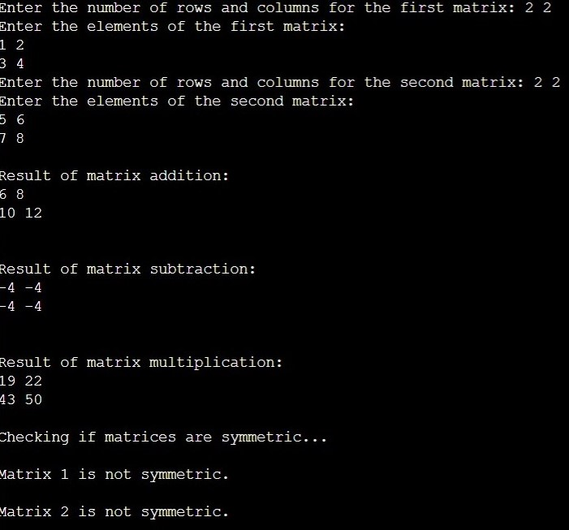

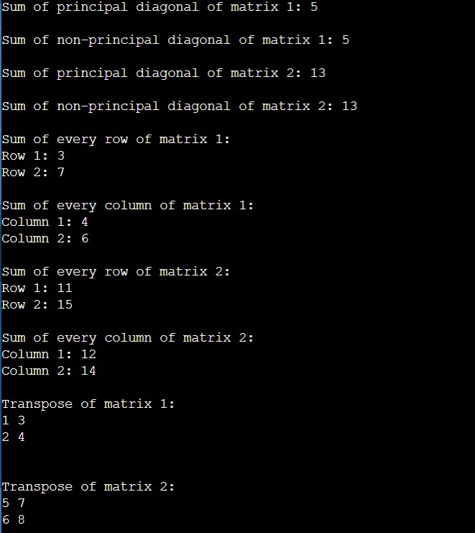

**Observation Book Pictures:**

